QR Code for PREZI: 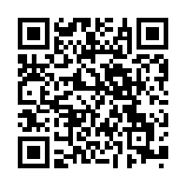

Weblink for Prezi: http://prezi.com/ebdpxed_78vx/?utm_campaign=share&utm_medium=copy

